EXTENDED ABSTRACT TEMPLATE

TITLE: BOLD, UPPER CASE, TIMES NEW ROMAN, 14 PT CENTERED

First A. Author^{1*}, Second B. Author, Jr.¹, Third Author², Fourth C. Author³

¹The University of Miyagi, 1-2-3 Katahira, Aoba-ku, Sendai 123-4567, JAPAN
²University of Sendai, St. ABC, STATE 12345, COUNTRY
³Aomba University, 800 Hirose Rd. Aoba District, Miyagi 987-6543, JAPAN

Abstract

This template is provided for authors preparing extended abstracts for the 11th JSME-KSME Thermal and Fluid Engineering Conference (J-K TFEC11), to be held in Okinawa, Japan, on October 22-25, 2025. Please adhere to the formatting guidelines to ensure consistency across all submissions. The main format of the paper is as follows: Text: Times New Roman (or equivalent), 11 pt type size, justified on both sides. Headings: Times New Roman, all caps, 12 pt. type size, centered. Page size A4 (210 × 297 mm); 20 mm borders on all sides; paper title starts at 40 mm from top of page except the first page. The Extended Abstract is transferred to PDF format and is uploaded the conference website. The abstract must be a single paragraph (150- 200 words), summarizing the objectives, methods , key results and conclusions of the paper. Please avoid abbreviations, diagrams, or references. It must be complete and understandable without reference to the text.

KEYWORDS: Convection, Computational methods, Heat exchanger, Cooling turbine blade, Film cooling, High temperature (Times New Roman, 10pt)

1. INTRODUCTION
Submissions must be 2-6 pages (including tables, figures and references) in A4 size (210 × 297 mm). Extremely short or long papers are discouraged. Color figures are acceptable. Final PDF file size must not exceed 4MB.
Authors must follow the formatting rules as demonstrated in this template.

2. PAPER FORMAT
The title should appear about 40 mm below the top edge of the page. It should be brief, clear and descriptive. Use bold, uppercase, 14 pt Times New Roman (except if formulae or symbols appear in the title), centered on the width of the typing area. Author names follow, using bold lowercase, and affiliations should be regular (not bold). A blank line must be left before and after the abstract. The header of each page includes Paper number (4 digit). Please substitute your paper number supplied by the secretariat of the conference. The number (reference number) is indicated on the acceptance letter. The footnote of the first page contains the email address of the corresponding author. It will be assumed that the corresponding author will represent the paper.

3. ABSTRACT AND KEYWORDS
A brief abstract (150-200 words) follows the affiliations. It should summarize the main contributions, methodology, and conclusions of the paper without using abbreviations, diagrams, or citations. Below the abstract, list 4-5 keywords to describe the key topics of the paper. Use 10 pt Times New Roman. Leave two blank lines after the keywords before the first main heading.

4. FIGURES AND TABLES
Figures should have centered captions below the image (e.g., "Fig. 1 Example of figure"). Tables must include captions above, aligned to the left (e.g., "Table 1 Example of table"). All numerical data should use SI units and periods for decimal points. Do not use punctuation at the end of equations. Align equal signs in stacked equations.

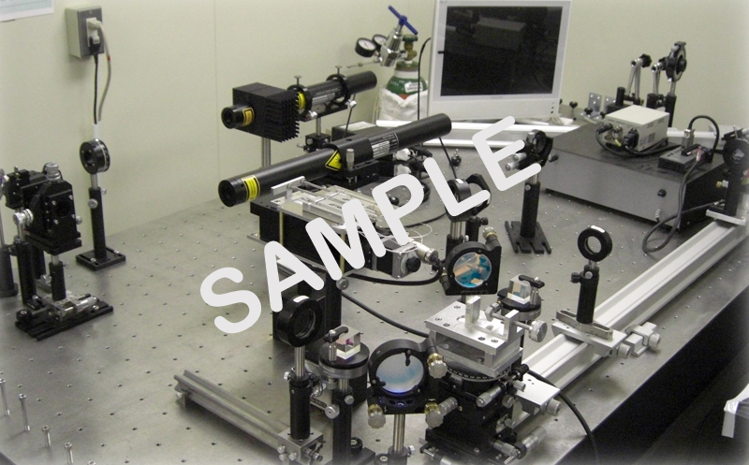
Fig. 1 Example of figure. The caption should be centered.

Table 1 Example of table. The caption should be located above the table and flush left.
Case | Diameter, (mm) | (Hz) | We | St
1 | 0.5 | 731 | 117 | 0.15
2 | 0.5 | 1799 | 620 | 0.16
3 | 1.3 | 198 | 124 | 0.17

4. CONCLUSIONS

Conclude the paper with key findings and implications. Do not repeat the abstract. The extended abstract in PDF format must be submitted before June 27, 2025.

REFERENCES
Reference List at the end of the paper must be numbered consecutively in the order they are mentioned, using Arabic numerals in square brackets and formatted according to the following samples. Incorrectly formatted reference lists will be returned to the author for correction before acceptance. Format references in 9pt Times New Roman, justified first line flush left, remaining lines indented.

[1] Guo, Z.Y., Zhu, H.Y., Liang, X.G., “Entransy - A physical quantity describing heat transfer ability,” Int. J. Heat Mass Transf., 50(13-14), pp. 2545-2556, (2007). Journal Paper
[2] Nield, D.A. and Bejan, A., Convection in Porous Media, New York: Springer-Verlag, pp. 125–176, (2005). Book
[3] Buyevich, A. and Alexandrov, D.V., Heat Transfer in Dispersions, Connecticut: Begell House, Available at http://www.edata-center.com/ebooks/b7f98f1e271b3e77a.html/ EBooks [accessed May 5, 2005] (2005). E-Books
[4] Yang, W. and Kim J.H. Eds., Rotating Machinery, New York: Begell House, (1992). Edited Book
[5] Nishikawa, K. and Ito, T., “Augmentation of Nucleate Boiling Heat Transfer by Prepared Surfaces,” In T. Mizushina and W.J. Yang, Eds., Heat Transfer in Energy Problems, Washington, D.C.: Hemisphere Publishing, pp. 111–1182, (1982). Chapters of Edited Book:
[6] Ma, T.M., “Effects of Geometrical Shapes of Reentrant Grooves on Boiling Heat Transfer from Porous Surfaces,” Heat Transfer 1986, Proc. of 8th Int. Heat Trans. Conf., vol. 4, pp. 2013–2018, (1987). Conference Proceedings
[7] Kasagi, N., Hasegawa, Y., Fukada, K. and Iwamoto, K., “Control of Turbulent Transport: Less Friction and More Heat Transfer,” Proc. of 13th Int. Heat Trans. Conf., IHTC14-23344, pp. 1-16, (2010). Conference Proceedings
[8] Richmond, J., Steady State Thermal Conductivity, Ph.D. Thesis, University of Connecticut, (2004). Dissertation
[9] Author, A.A. and Author, B.B., Title of document. Retrieved month day, year, from http://Web address, (Date of publication). Webpages: Nonperiodical Web Document
[10] Author, A.A. and Author, B.B. Title of article. In Title of book or larger document (chapter or section number). Retrieved month day, year, from http://www.someaddress.com/full/url/, (Date of publication). Chapter or Section of a Web document
[11] Author, A.A., & Author, B.B., “Title of article,” Title of Journal, volume number. Retrieved month day, year, from http://www.someaddress.com/full/url/, (Date of publication). Online Scholarly Journal Article

